**DAILY ONLINE ACTIVITIES SUMMARY**

|  |  |  |  |  |  |  |  |  |
| --- | --- | --- | --- | --- | --- | --- | --- | --- |
| **Date:** | **20/05/20** | | | | | **Name:** | **ASHIKA** | |
| **Sem & Sec** | **6th sem ‘A”** | | | | | **USN:** | **4AL17CS016** | |
| **Online Test Summary** | | | | | | | | |
| **Subject** | | **SSCD** | | | | | | |
| **Max. Marks** | | **30** | | **Score** | | | **22** | |
| **Certification Course Summary** | | | | | | | | |
| **Course** | **FRONT END HTML CERTIFICATION**  **https://www.greatlearning.in/academy** | | | | | | | |
| **Certificate Provider** | | | **greatlearning** | | **Duration** | | | **3.5 HOUR** |
| **Coding Challenges** | | | | | | | | |
| **Problem Statement: NO** | | | | | | | | |
| **Status: Absolute and relative path ,hr and br tag and image,more on input elements,and tables creation with some assignment and quiz and program** | | | | | | | | |
| **Uploaded the report in Github** | | | | | **yes** | | | |
| **If yes Repository name** | | | | | **Online report(username:ASHIKA-05)** | | | |
| **Uploaded the report in slack** | | | | | **yes** | | | |

Online Test Details: (Attach the snapshot and briefly write the report for the same)

Certification Course Details: (Attach the snapshot and briefly write the report for the same)

Coding Challenges Details: (Attach the snapshot and briefly write the report for the same)

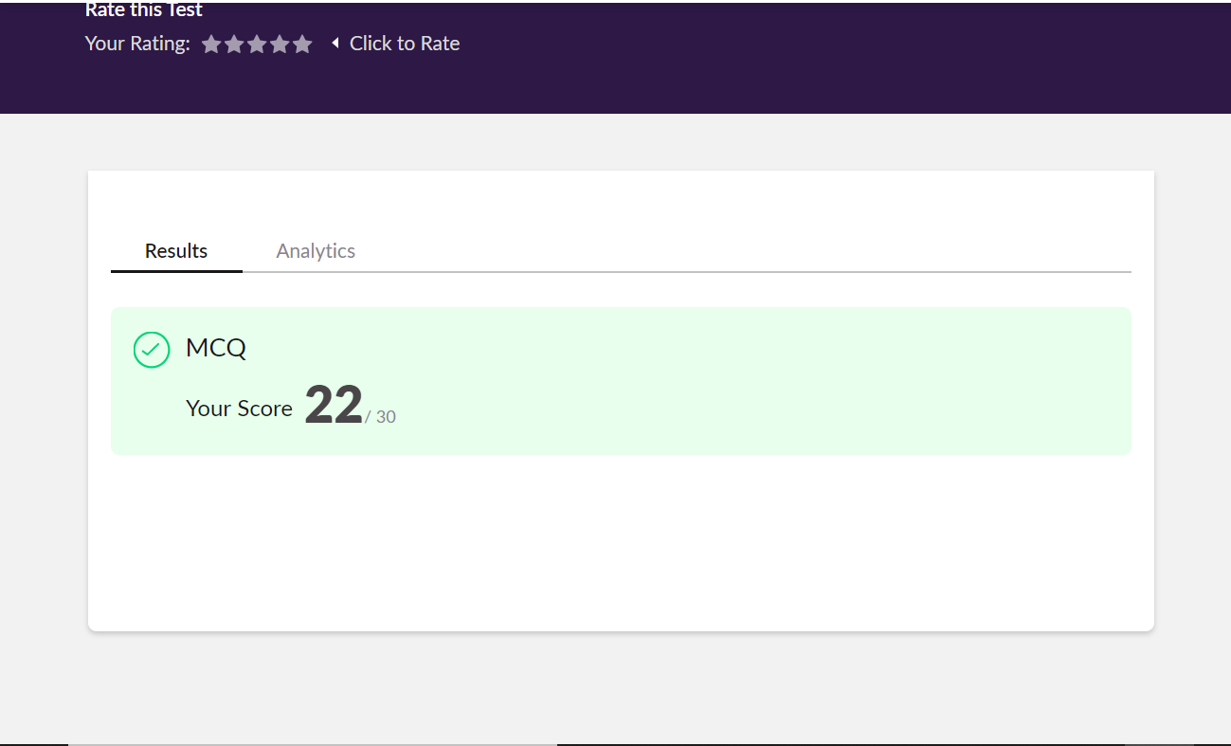

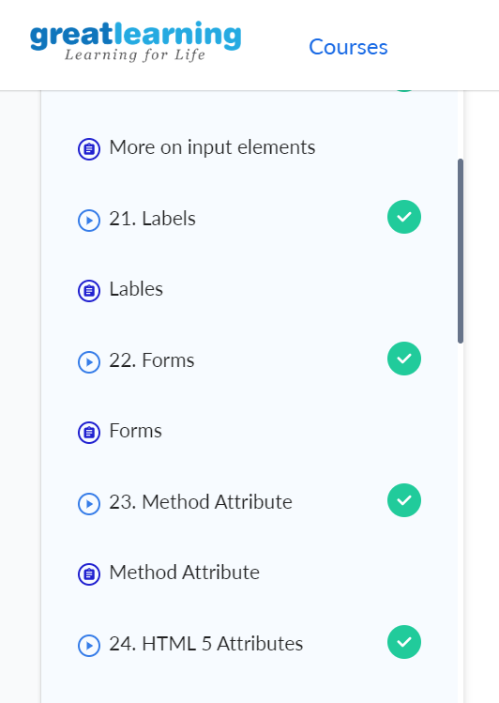

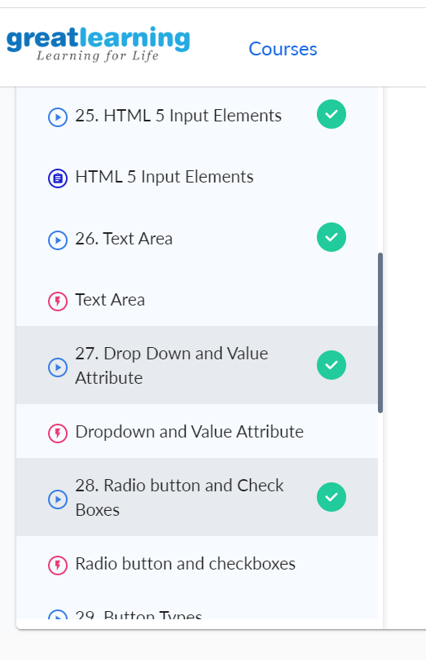

1. Write a C Program to Reverse a Linked List in groups of given size.

Test Case 1:  
If a linked listis: 1 → 2 → 3 → 4 → 5 → 6 → 7 → 8  
The value of size k is 2  
Then the linked list looks like: 2 → 1 → 4 → 3 → 6 → 5 → 8 → 7

Test Case 2:  
If a linked listis: 1 → 2 → 3 → 4 → 5 → 6 → 7 → 8  
The value of size k is 3  
Then the linked list looks like: 3 → 2 → 1 → 6 → 5 → 4 → 8 → 7

#include<stdio.h>

#include<conio.h>

#include<stdlib.h>

typedef struct node

{

int data;

struct node *next;

}node;

void reverse(node *head)

{

if(head == NULL)

return;

if(head -> next == NULL)

return;

reverse(head->next);

head->next->next = head;

head->next = NULL;

}

node *swap_in_a_group(node *start , int k)

{

node *p , *q ,*new_start , *temp;

int cnt;

p = start;

cnt = 0;

while(cnt != k-1)

{

if(p->next == NULL)

{

return start;

}

p = p->next;

cnt++;

}

new_start = p;

q = new_start;

while(1)

{

p = start;

temp = q->next;

if(temp == NULL)

{

reverse(p);

return new_start;

}

q->next = NULL;

q = temp;

start = temp;

cnt = 0;

while(cnt != k-1)

{

if(temp->next == NULL)

{

reverse(p);

p->next = q;

return new_start;

}

temp = temp->next;

cnt++;

}

reverse(p);

p->next = temp;

q = temp;

}

return new_start;

}

int main()

{

int a , i , n , cnt , k=4 , flag = 1;

node *p,*q,*start;

printf("Enter the number of nodes");

scanf("%d",&n);

printf("Enter all the nodes \n");

p = (node*)malloc(sizeof(node));

scanf("%d",&a);

p->data = a;

p->next = NULL;

start = p;

for(i=1;i<n;i++)

{

q = (node*)malloc(sizeof(node));

scanf("%d",&a);

q->data = a;

q->next = NULL;

p->next = q;

p = p->next;

}

printf("\n Enter K ");

scanf("%d",&k);

printf("\n swapped list==");

p = swap_in_a_group(start , k);

while(p!=NULL)

{

printf("%d ",p->data);

p = p->next;

}

return 0;

}

**Output:**

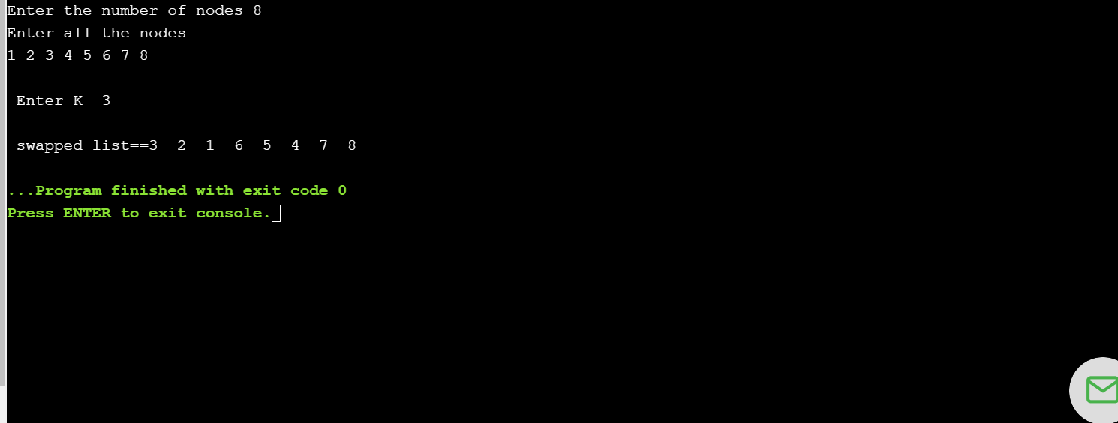

2.Write a simple Python program to implement Diffie–Hellman Key Exchange Example

**sharedPrime = 23**

**sharedBase = 5**

**aliceSecret = 6**

**bobSecret = 15**

**print( "Publicly Shared Variables:")**

**print( " Publicly Shared Prime: " , sharedPrime )**

**print( " Publicly Shared Base: " , sharedBase )**

**A = (sharedBase**aliceSecret) % sharedPrime**

**print( "\n Alice Sends Over Public Chanel: " , A )**

**B = (sharedBase ** bobSecret) % sharedPrime**

**print("\n Bob Sends Over Public Chanel: ", B )**

**print( "\n------------\n" )**

**print( "Privately Calculated Shared Secret:" )**

**# Alice Computes Shared Secret: s = B^a mod p**

**aliceSharedSecret = (B ** aliceSecret) % sharedPrime**

**print( " Alice Shared Secret: ", aliceSharedSecret )**

**bobSharedSecret = (A**bobSecret) % sharedPrime**

**print( " Bob Shared Secret: ", bobSharedSecret )**

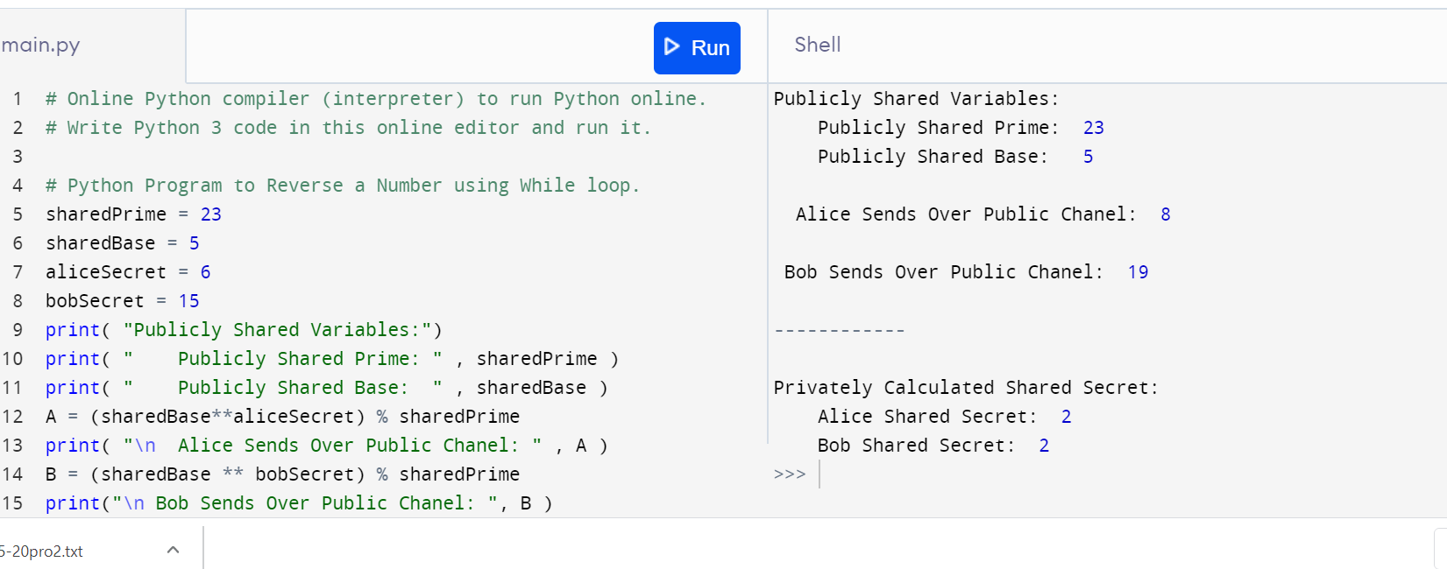

4.Write Python Program to Reverse a Given Number  
This is a Python Program to reverse a given number.  
Problem Description  
The program takes a number and reverses it and store it in another variable and show it

n=**int(input("Enter number: "))**

**rev=0**

**while(n>0):**

**dig=n%10**

**rev=rev*10+dig**

**n=n//10**

**print("Reverse of the number:",rev)**



**package** prog1;

**import** java.sql.Connection;

**import** java.sql.DriverManager;

**import** java.sql.ResultSet;

**import** java.sql.ResultSetMetaData;

**import** java.sql.SQLException;

**import** java.sql.Statement;

**public** **class** ResultsetMetaData{

**public** **static** **void** main(String a[]){

Connection con = **null**;

Statement st = **null**;

ResultSet rs = **null**;

**try** {

Class.*forName*("oracle.jdbc.driver.OracleDriver");

con = DriverManager.

*getConnection*("jdbc:oracle:thin:@<hostname>:<port num>:<DB name>"

,"user","password");

st = con.createStatement();

rs = st.executeQuery("select * from emp");

ResultSetMetaData rsmd = rs.getMetaData();

**int** columnCount = rsmd.getColumnCount();

**for**(**int** i=0;i<=columnCount;i++){

System.***out***.println(rsmd.getColumnName(i));

System.***out***.println(rsmd.getColumnType(i));

}

} **catch** (ClassNotFoundException e) {

// **TODO** Auto-generated catch block

e.printStackTrace();

} **catch** (SQLException e) {

// **TODO** Auto-generated catch block

e.printStackTrace();

} **finally**{

**try**{

**if**(rs != **null**) rs.close();

**if**(st != **null**) st.close();

**if**(con != **null**) con.close();

} **catch**(Exception ex){}

}

}

}

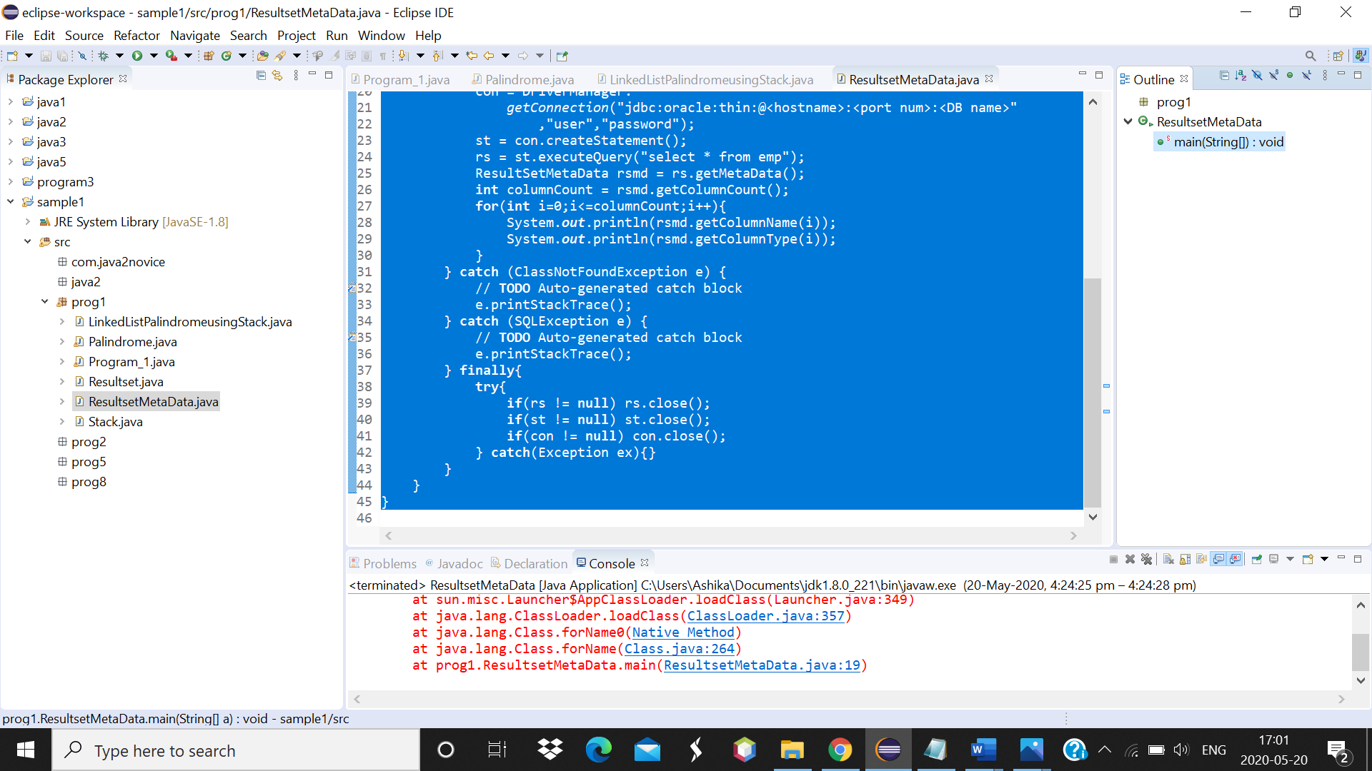

5. Python Program to Exchange the Values of Two Numbers using ^ (exclusive or operator)

x=int(input("Enter value of x: "))

y=int(input("Enter value of y: "))

x = x ^ y;

y = x ^ y;

x = x ^ y;

print ("After Swapping: x = ", x, " y =", y)

**Output:**

